Project Title: Disease prediction using questionaire

Team ID: Team_4335

Team Leader Name:

Nisarg Patel

Team Member Names:

Shreya Panwala

Priyanshi Patel

Utsav Patel

Dev Desai

Team Leader Email :Nisarg1463@gmail.com

Institute name :R.N.G. Patel Institute of Technology

Abstract:

Your hospital website is based on the concept of getting prescriptions of health from online sources. It takes a description as input and use nlp to find the root of the problem. In this busy world people rarely go to hospital when it comes to small diseases. But those small diseases can sometimes lead to big massive problem that are some times deadly. This website will be available free on the net and accessible from anywhere 24x7.

Introduction

Your hospital is a website that will help to diagnose any basic disease and help with proper medication. People avoid going to hospitals due to long waiting period and high rate of payments even for small disease. We are using nlp model to decide which disease is close match with the problem described. Then that response is shown to the user on the web page. This website will be available 24x7 this will help the problem of waiting in long lines. And the free cost will help save those large payments. You can diagnose anytime anywhere as much as you want. This factor of availability will bring new consumers more and in addition to that free price can increase popularity more.

Technologies

Web development, Python, NLP, JSON

Results :

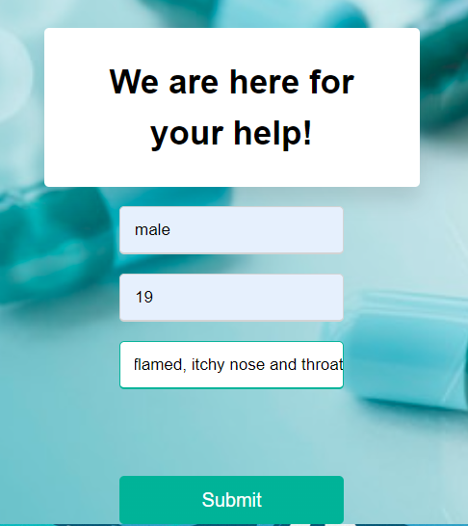

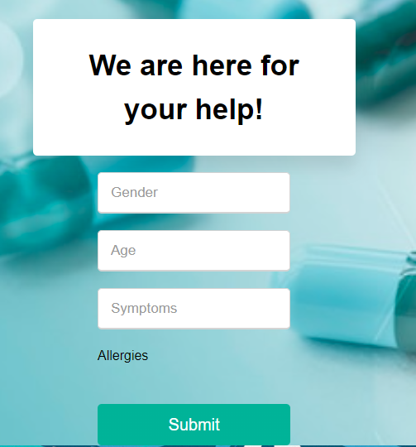

Summerizing the points:-

It is available 24x7.

It is accessible from anywhere.

It is free of cost.

It saves time.

It helps in diagnosing problems.

Limitations:-

Due to lack of data only two diseases are given.

Need a large amount of medical data.

Conclusion

In conclusion this project has the capacity to save a top of lives. As well as it can also save time of users. With right amount of data, it has a scope to grow further and expand into an uncharted field. The merger of AI and health care can bring a lot of inovations for both doctors and patients.

Future Scope

The scope of this application is huge as with the increase in the pace of daily life people have less and less time for their own health. With right amount of data, we can make a model strong enough to detech any kind of disease with just the description of the patient. This can also help in saving many invalueable lives what would have been lost due to wrong treatement.

Roles:-

Web team:-

Shreya

Priyanshi

Dev

AI team:-

Nisarg

Utsav